Data Science

By Zeeshan Usmani

1. Introduction

Data

1.Resources

1. Data Science Book includes
   * Important tools, packages and languages for data science.
   * Some resources, applications and case studies in this filed.
   * Two Simple projects that the contain end to end data science project.
2. R programming Book includes
   * R is heavily used in data science in academic discipline in Bachelors (FYP), Masters (Thesis), and even in PHD R is crucial.
3. Python Programming.
4. Ek Tha Algorithm Part 01:
   * Includes a story that try to explain algorithms and their applications of computer science and data science.
5. Ek Tha Algorithm Part 02/ Digital Jasoos.
   * Try to explain Search and Clustering algorithms.
6. Artificial Intelligence
7. Machine Learning 480 pages.
   * Authors puts a lot of efforts writing this book
   * It includes all popular ML Algorithms with examples that a non-technical person can understand.
8. Kaggle.
   * The biggest community of data scientist.
   * There are about 200 Kaggle Grand Masters, 1500 Kaggle Masters.
   * No one is earning less then a half million dollar yearly.
   * Your Kaggle Rank is enough to prove your skills.
9. Introduction to blockchain with case studies.
   * This book includes many cases studies in Pakistan
   * How to run population sensors.
   * How to run Elections
   * Sexual harassment Registry.
10. Block Chain and Crypto currency.
    * How decentralize system is transforming world’s economy
    * And how we connect Data Science in Decentralized system.

2,3. How to teach data science

There are different ways Data Science is being taught.

After doing 175+ Courses in past 3-4 years Dr. Zeeshan make this video.

1. **Academic Way** (Philosophy, Theory, Math Statistics Calculus, Algebra, Dry)
2. **Professional Way** (Very basic things, Titanic, Sample data)
3. **MOOCs Way** (Coursera, Udacity, Udemy, Lynda etc) Academic Focused same math Statistics, Calculus, non-realistic assignments.
4. **On-job Training** (the best way is to learn to get paid, but the experience you get might be very limited, narrow, specific to that company.)

Every person has their own way of learning but none of the above is amazing instead Dr. Zeeshan has something special to offer which is a mixture of all the above.

* **My Way (**Story Telling, Live Projects, Guests Lectures, Books, pdf,
  + Case-Studies like Adhar card, Daraz, Food Panda, start-ups and companies around you,
  + Assign are based on case studies
  + After doing all these assignments you will have 4, 5 ideas about how to develop and launch your own product as a start-up or as an income stream.
  + This is the most enjoyable and effective way of learning Data Science.

4.Pre-Requisites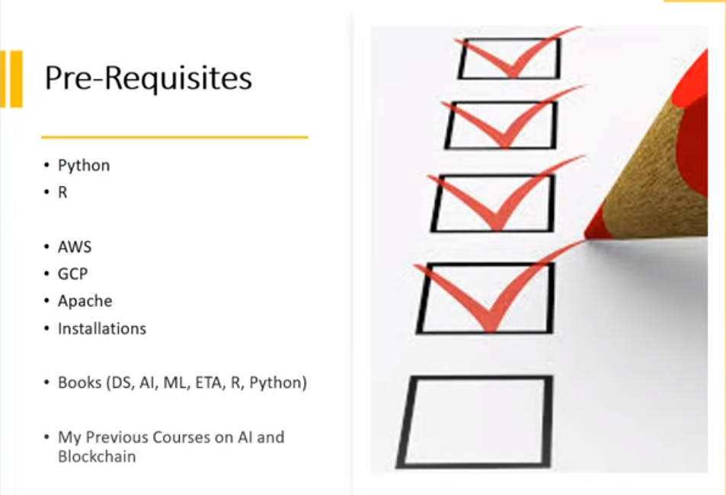

5. What is Data Part 1

Before diving into the buzz-word Data Science and how to leverage maximum advantage from Data Science. We have to understand the following fundamental terminologies.

* What is Data?
* What is Science?
* What is Scientific Method?
* Who is Data Scientist?

**Data**

* Data is the smallest unit of any kind of information.

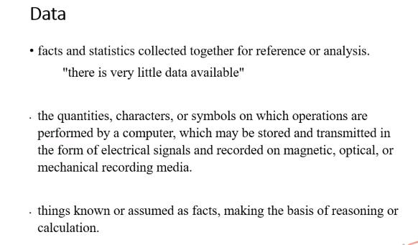

* These Facts are used to solve any kind problem.
* But where data come from?
* A human is a walking fire-hose of data from Adam.
* Data flows all the time from a human being even before birth and in some cases this flow continue after its death.
* In this era of Information technology this is become possible for the first time in the history that an average human being can collect, transforms, organise, and analyse the data thanks to the technology that bring us the storage and computational power and ultimately the field of data science.
* A Data Scientist is usually collects, process, comparing different data-sets and see how these different datasets are related to each other, how to connect them and form hypothesis, conclusions and end results.

**Assignment/Activity: data collection**

* Let’s assume you have given a task to collect data about all the products you are using in any form for example cloths, foot ware, home-appliance, electronics, and other accessories.
* So, you can collect 300-500 data points about yourself.

6,7 What is Data Part 2,3

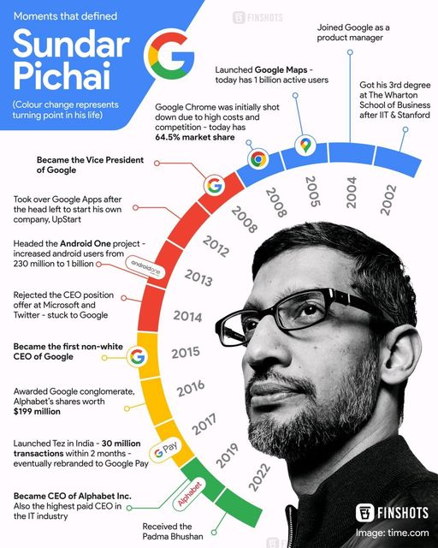

**Data Before Computer Science**

1. Take a Walk (bench, tree)
2. Go Shopping (shoes)
3. Travel (plain, train, road) where (turkey, Iran)
4. Visit Zoo (animals, birds)
5. Look Around (room, market, road)
6. How many products you touch in a Day (**Assignment**)
7. Meet Your Family (age, weight, dob, salary, education)
8. Meet a Stranger
9. Think about Business
10. Nature
11. Religion (kirman katibeen, nama e amal )
12. Country

*Data Science in nothing but a way of Thinking.*

8.9 What is Data Part 4

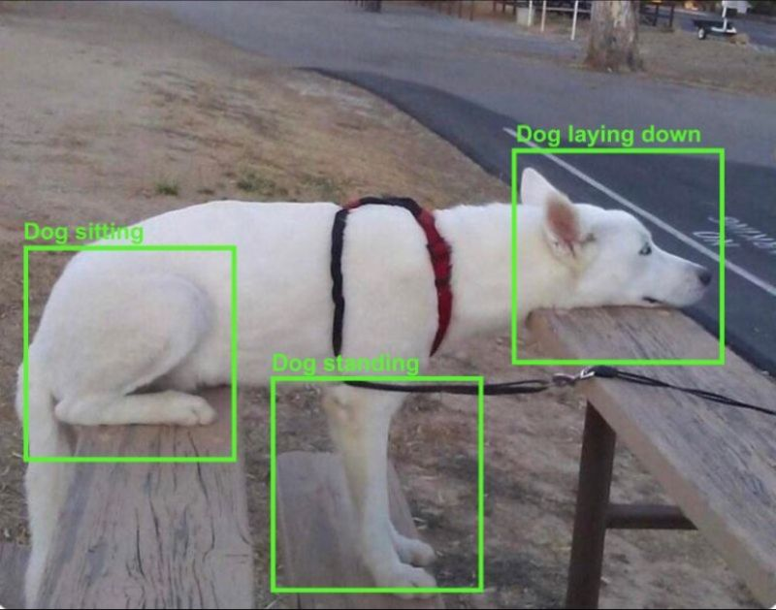

1. It’s like a Colour.
2. Data without context is just misleading and harmful.
   1. Say Number 76
3. “Data needs a story to tell a story”
4. Data Should be able to form insights which will be used to make informed decision making.
5. Elm and Shaoor (look at history everything is improved)

10. What is Science

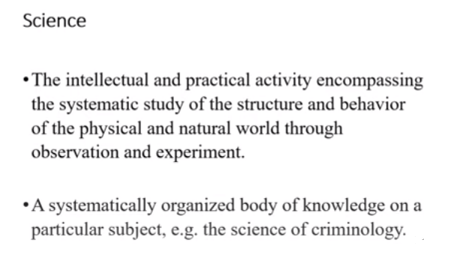

Anything that be observed, experience, and can be measure on the basis different parameters.